CBO NIGZ

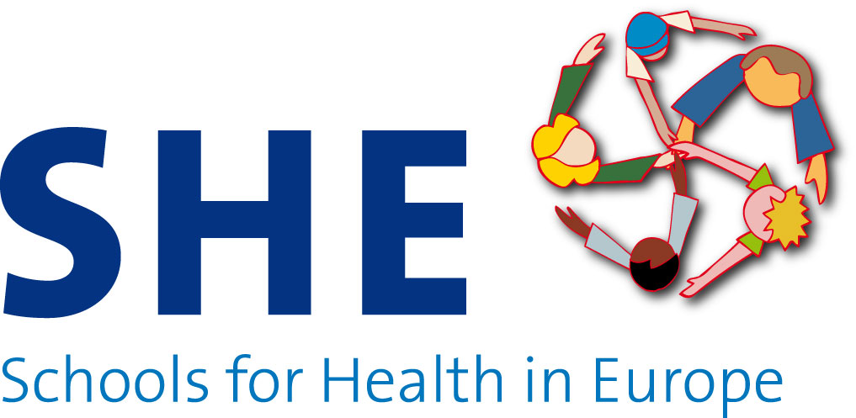

SHE work plan 2013

DRAFT

Silvia de Ruiter
Goof Buijs

November 2012

General information SHE network

The Schools for Health in Europe (SHE) network was founded in 1992 by WHO Euro, the Council of Europe and the European Commission. There are 43 participating countries covering the European region, including the EU member states, EEA countries, Eastern Europe and Central Asia. The network has evolved from a pilot project of national networks into supporting sustainable national programmes on health promoting schools.

The overall aim of the SHE network is to improve the health of children and young people in Europe, including reducing health inequalities, through a specific focus on schools as a setting for health promotion. The main objective of the SHE network is to support organisations and professionals to further develop and sustain school health promotion in each country by providing the European platform for school health promotion.

The SHE network focuses on making school health promotion an integral part of policy development in the education and health sector in Europe. SHE encourages each member country to develop and implement a national policy on school health promotion, building on the experiences within the country, within Europe and globally.

A ‘health promoting school’ is a school that implements a structured and systematic plan for the health, well-being and the development of social capital of all pupils and of teaching and non-teaching staff. The whole school environment is viewed as an important area for promotion of health and for learning about health.

In April 2013 the SHE strategic plan 2012-2016 will be ratified during the SHE assembly meeting. This outlines the future development of the SHE network.

Objectives and main activities SHE 2013

The activities by the SHE secretariat at CBO are supported by a financial contribution from the EU as the 2013 operating grant and by the annual contribution from WHO EURO. An external evaluator (based on a CBO tender procedure) will evaluate the activities in the SHE network from 2011 till 2013.

Objectives

The objectives of the SHE network for 2013 are:
- Provide support to the members of the SHE network
- Capacity building on school health promotion
- Advocacy on school health promotion
- Supporting research on school health promotion
- Support EECA countries

The main activities supporting the objectives are described below.

Provide support to the members of the SHE network
The SHE secretariat located at CBO focuses on the support of the members of the SHE network. The SHE secretariat organises the 2013 SHE assembly meeting, maintains the website and helpdesk and issues the electronic SHE newsletter. The secretariat encourages the SHE members to collaborate with regional and cross-boarder networks to strengthen their national networks.
In order to reinforce the SHE network membership will be open to active regional health promoting school networks. The SHE secretariat will intensify promotional activities for recruiting regional HPS networks.

Capacity building on school health promotion
In 2013 the SHE secretariat will deliver a support programme for professional development and capacity building on school health promotion.
- The SHE Secretariat will organise a workshop on evolving management skills for national coordinators on planning and evaluation, logic modelling, strengthening partnerships and performance management.
- The Danish School of Education from the Aarhus University will organise the 2013 SHE Summer School focusing on theory, research and practice of school health promotion.
- A third activity includes encouraging collegial consultation through providing an online community and through 3 consultancy/advocacy visits.
For the EECA countries in the SHE network the 2013 programme is included as a separate chapter in the work plan.

Advocacy on school health promotion
- The SHE secretariat will develop a promotional leaflet on the SHE activities 2013.
- The SHE secretariat will develop a country profile for each of the SHE member countries concerning the current situation on health promoting schools. A draft profile will be developed, pretested and information will be collected and included on the SHE website.
- Also an online manual for schools on how to become a health promoting school will be developed, pilot tested and made available on the SHE website in 3 language versions. For promoting the online manual a supporting leaflet and a dissemination plan will be developed.
- Two factsheets will be developed. The topics of the factsheets are:
- State of the art of health promoting schools in EU member states. Information will be based on the HPS country profiles
- The evidence of the health promoting school approach with a focus on reducing health inequalities and sustainable development.

Supporting research on school health promotion
- A meeting for the members of the SHE research group will be organised, including a writing workshop focused on improving the quality of publications focusing on school based health promotion.

Support EECA countries
In 2013 the SHE network receives support from WHO Euro for maintaining the SHE secretariat and to support the work of the national coordinators in the Eastern European and Central Asian (EECA) countries. The WHO Collaborating Centre status on School Health Promotion will be transferred from NIGZ to CBO.
Specific activities for 2013 include:

  - Capacity building and training
Plan, deliver, coordinate and evaluate 1 training session for SHE national coordinators from the Eastern European and Central Asian member states. The EECA workshop will be combined with the 2013 SHE assembly meeting. WHO EURO funding will be used for travel and subsistence for 10 EECA SHE national coordinators.

  - Ongoing technical support
Provide technical support looking to develop an infrastructure on which to build and develop their national health promoting school programme in EECA countries. In Albania for 2013 a train-the-trainers event will be organised. In another EECA country (Kyrgyzstan/Armenia) a training event on HPS will be delivered.

  - Country visits
Two country visits are scheduled to EECA countries to advocate and support the development and implementation of their national health promoting school programme with a focus on reducing health inequalities.

  - Travel and subsistence SHE Planning Committee meeting
Travel and subsistence from WHO EURO budget is available for one SHE national coordinator representing the Eastern European and Central Asian member states as a member of the SHE planning committee, one 1-day meeting

  - Material costs
WHO EURO budget will be available to facilitate the introduction, translation and dissemination of SHE and HEPS deliverables, with a focus on promoting healthy eating and physical activity in the school setting, translations of core documents into Russian on SHE website, promotion materials SHE or to support national tool development.

Deliverables SHE 2013

Objective 1: provide support to the members of the SHE network

Activity: Organising the 2013 SHE assembly meeting in April 2013
Target group: Members of the SHE network
Timeline: January – June 2013
Expected outcome: 40 participants and stronger national networks on school health promotion
Deliverable: Report of the SHE assembly meeting

Activity: Maintain the SHE website and helpdesk
Target group: (Potential) members of the SHE network and regional coordinators
Timeline: January – December 2013
Expected outcome: 10.000 site visits and 100 questions
Deliverable: Chapter in the technical and financial report

Activity: Deliver four electronic SHE newsletters
Target group: (Potential) members of the SHE network and regional coordinators
Timeline: March, June, September and December
Expected outcome: 4 electronic SHE newsletters (with 650 subscriptions)
Deliverable: 4 electronic SHE newsletters

Activity: Extending the SHE network with regional and/or cross-border networks
Target group: Regional and/or cross-border health promoting school coordinators
Timeline: January – December 2013
Expected outcome: Extension of SHE network with 10 regional and/or cross-border networks and stronger national networks on school health promotion
Deliverable: Chapter in the technical and financial report

Activity: Share information about school health promotion through social media
Target group: (potential) members of the SHE network and regional coordinators
Timeline: January – December 2013
Expected outcome: Twitter account linked to the SHE website/ Face book page
Deliverable: Chapter in the technical and financial report

Objective 2: capacity building on school health promotion

Activity: Organise a workshop on management skills
Target group: National coordinators
Timeline: April 2013
Expected outcome: 15 participants. Increased professional development of the participants
Deliverable: Chapter in the technical and financial report

Activity: Organise the 2013 SHE Summer School
Target group: Professionals with an interest in school health promotion; researchers, PhD students, practitioners and programme developers
Timeline: March – August 2013
Expected outcome: 25 participants. Increased professional development of the participants.
Deliverable: SHE Summer School Leaflet. Training materials will be made available through the SHE website. Chapter in the technical and financial report.

Activity: Encourage collegial consultation through an online community and consultancy / advocacy visits
Target group: SHE National Coordinators
Timeline: April, September, November
Expected outcome: 3 consultancy/advocacy visits; online community.
Deliverable: Chapter in the technical and financial report

Objective 3: advocacy on school health promotion

Activity: Develop a leaflet on the work plan SHE 2013
Target group: Members of the network, researchers, policy makers, practitioners and schools with an interest in school health promotion.
Timeline: January – February 2013
Expected outcome: Increased visibility of the SHE network and the 2012 EU Public Health Programme
Deliverable: Leaflet SHE 2013

Activity: Development of an online manual for schools
Target group: Members of the network, practitioners and schools with an interest in school health promotion.
Timeline: January – October 2013.
Expected outcome: A user-friendly online tool for schools
Deliverable: Online manual available in 3 EU languages

Activity: Development of a leaflet for schools
Target group: Members of the network, practitioners and schools with an interest in school health promotion.
Timeline: July – October 2013
Expected outcome: Increased visibility of the SHE network and a user friendly tool on school health promotion.
Deliverable: Leaflet for schools

Activity: Development of two fact sheets
Target group: Members of the network, researchers, policy makers, practitioners and schools with an interest in school health promotion.
Timeline: Factsheet one: January – April 2013
Factsheet two: June – September 2013
Expected outcome: Increased visibility of the SHE network and user friendly tools on school health promotion
Deliverable: - a fact sheet on the state of the art of health promoting schools in EU member states;
- a fact sheet on the evidence of the health promoting school approach with a focus on recuing health inequalities and sustainable development

Activity: Development of a dissemination plan
Target group: SHE secretariat, SHE planning committee, SHE international advisory board.
Timeline: January – March 2013
Expected outcome: Increased visibility of the SHE network
Deliverable: Dissemination plan SHE 2013

Objective 4: supporting research on school health promotion

Activity: SHE Research Group meeting including writing workshop
Target group: Members of the SHE Research Group
Timeline: October 2013
Expected outcome: Increased writing skills and collaboration among Research Group members
Deliverable: Chapter in the technical and financial report.

Objective 5: Support EECA countries

Activity: Plan, deliver, coordinate and evaluate a EECA workshop
Target group: SHE national coordinators from EECA countries
Timeline: February – June 2013
Expected outcome: 10 participants. Increased professional development of the participants.
Deliverable: Report on the EECA workshop available on the SHE website and an article in the SHE newsletter.

Activity: Technical support to develop an infrastructure for a national health promoting school programme
Target group: SHE national coordinators from EECA countries
Timeline: January – December 2013
Expected outcome: Two training events; one in Albania, one in Kyrgyzstan/Armenia. Increased professional development
Deliverable Report on the training events.

Activity: Support representation EECA countries in SHE planning committee
Target group: One SHE national coordinator representing the EECA countries as a member of the SHE planning committee
Timeline: January – December 2013
Expected outcome: One SHE planning committee meeting with representation from the EECA countries
Deliverable: Minutes of the SHE planning committee meeting

Activity: Facilitate the introduction, translation and dissemination of SHE and HEPS deliverables
Target group: SHE national coordinators from EECA countries
Timeline: January – December 2013
Expected outcome: The introduction, translation and dissemination of SHE and HEPS deliverables, with a focus on promoting healthy eating and physical activity in the school setting. Translations of core documents into Russian on SHE website. Promotion materials SHE or to support national tool development.
Deliverable: Translated documents (into Russian) available on the SHE website.

Budget 2013 SHE Network

Including EU operating grant 2013 and contribution WHO EURO

Income 2013

Operating grant SHE 2013 € 149.906,-
Contribution WHO EURO € 80.000,-
-------------
Total NIGZ SHE 2013 € 249.844,-

Expenses 2013

Work for operating grant SHE 2013 € 149.906,-
EECA work € 80.000
-------------
Total expenses NIGZ SHE 2013 € 249.844,-

